Prototyping Interrupt Service Routines for the Omega Blade

Christian Coffield

ECEN4013

October 18, 2015

## Flowchart and Diagram of I/O

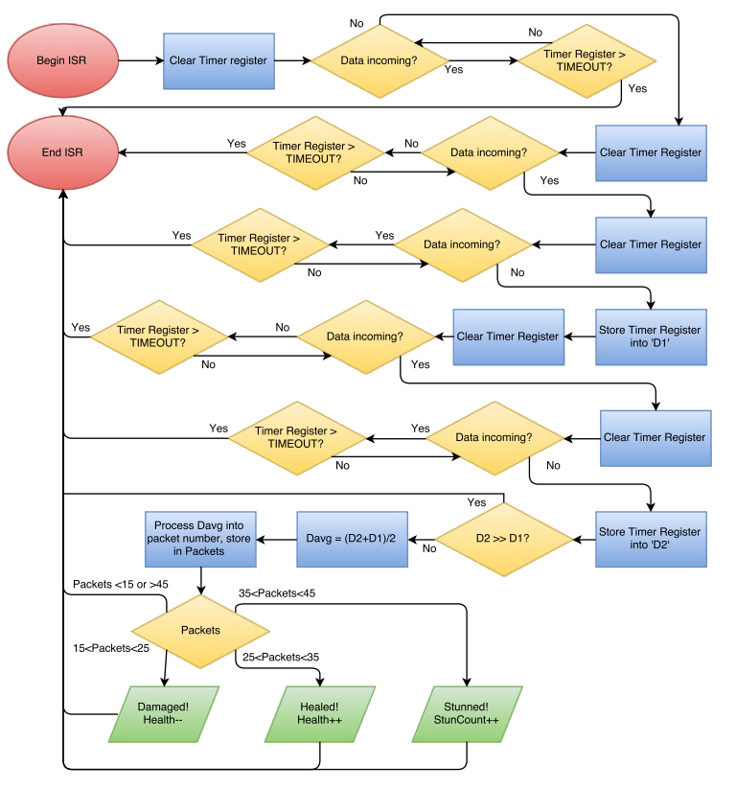

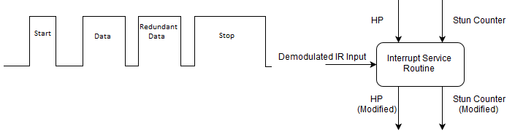

## Expected input and Output

### Hardware Input

|  |  |  |
| --- | --- | --- |
| **Name** | **Description** | **Expected Value** |
| Damage Packet | 20 on-bursts in the standard MIRP format, demodulated. | Digital pulse wave: 178.5us followed by 357us burst followed by 357us burst followed by 2678.5us burst. |
| Health Packet | 30 on-bursts in the standard MIRP format, demodulated. | Digital pulse wave: 178.5us followed by 535.5us burst followed by 535.5us burst followed by 2678.5us burst. |
| Stun Packet | 40 on-bursts in the standard MIRP format, demodulated. | Digital pulse wave: 178.5us followed by 714us burst followed by 714us burst followed by 2678.5us burst. |

### Software Input

|  |  |  |
| --- | --- | --- |
| **Name** | **Description** | **Expected Values** |
| HP | Record of weapon's current health. | 0 <= HP <= 50 |
| StunCount | Counter to determine how long, if at all, the weapon must be stunned. | 0 <= StunCount <= 65535 |

### Software Functions

|  |  |  |  |
| --- | --- | --- | --- |
| **Name** | **Description** | **Inputs** | **Outputs** |
| main | Checks the health and stun variables for changes, lights corresponding LED, resets to default. | StunCount, HP | StunCount, HP |
| init_ISR | Sets up RA4 as an interrupt-on-change pin, and initializes a timer for measurements. | N/A | N/A |
| ISR | Determines the length of the data pulse and determines what type of packet was received. | Digital MIRP, StunCount, HP | StunCount, HP |

### Hardware Output

|  |  |  |
| --- | --- | --- |
| **Name** | **Description** | **Expected Results** |
| Red LED | Indicates damage has been received. | Lights for 200ms upon damage packet received. |
| Green LED | Indicates healing has been received. | Lights for 200ms upon heal packet received. |
| White LED | Indicates stun has been received. | Lights for 200ms upon stun packet received. |

### Software Output

|  |  |  |
| --- | --- | --- |
| **Name** | **Description** | **Expected Values** |
| HP | Modified record of weapon's current health. | Previous value, or previous value +/- 1 |
| StunCount | Modified counter to determine the length of a stun. | Previous value, or previous value +1 |

